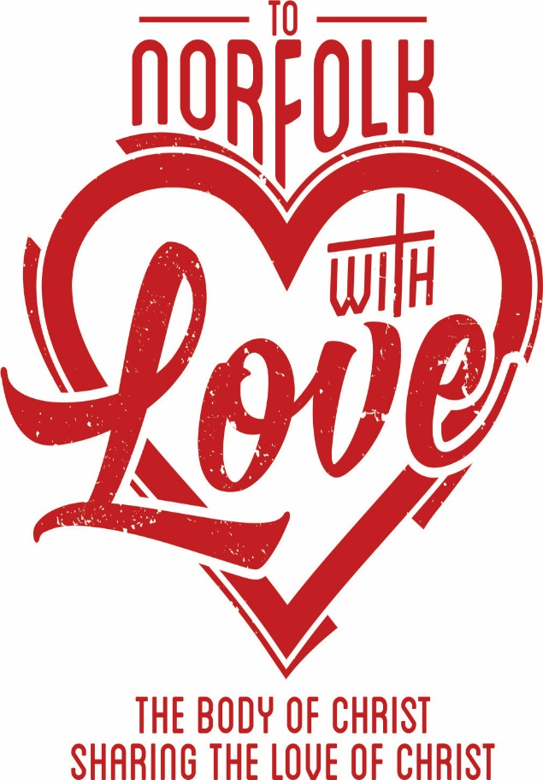

**Saturday, September 11**

**Join with us to serve and to share God’s Love with Norfolk!**

**FREE Childcare for Volunteers**

**FREE Lunch at Our “After Party”**

**FREE T-shirt if Signed up by Aug 30th**

**Register Today or Get More Info**

**@ tonorfolkwithlove.com**



**Saturday, September 11**

**Join with us to serve and to share God’s Love with Norfolk!**

**FREE Childcare for Volunteers**

**FREE Lunch at Our “After Party”**

**FREE T-shirt if Signed up by Aug 30th**

**Register Today or Get More Info**

**@ tonorfolkwithlove.com**